36 : grep –ni –E “h[^I].\*o$”

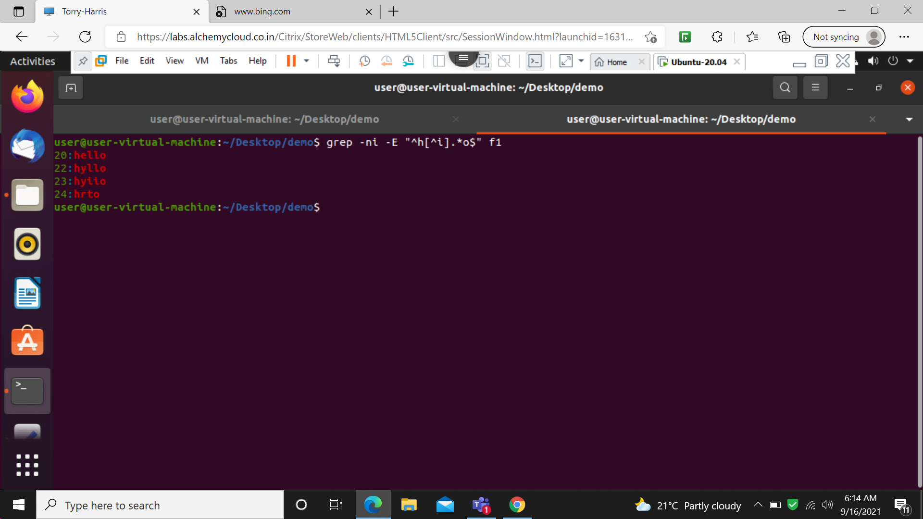

37: grep –ni –E “[A-Z].\*$”

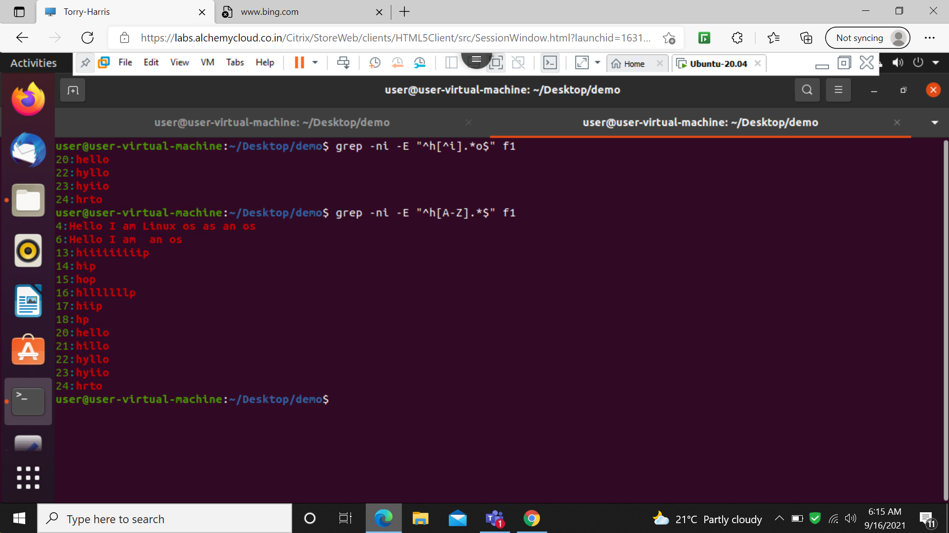

38: grep –ni –E “[a-c].\*$”

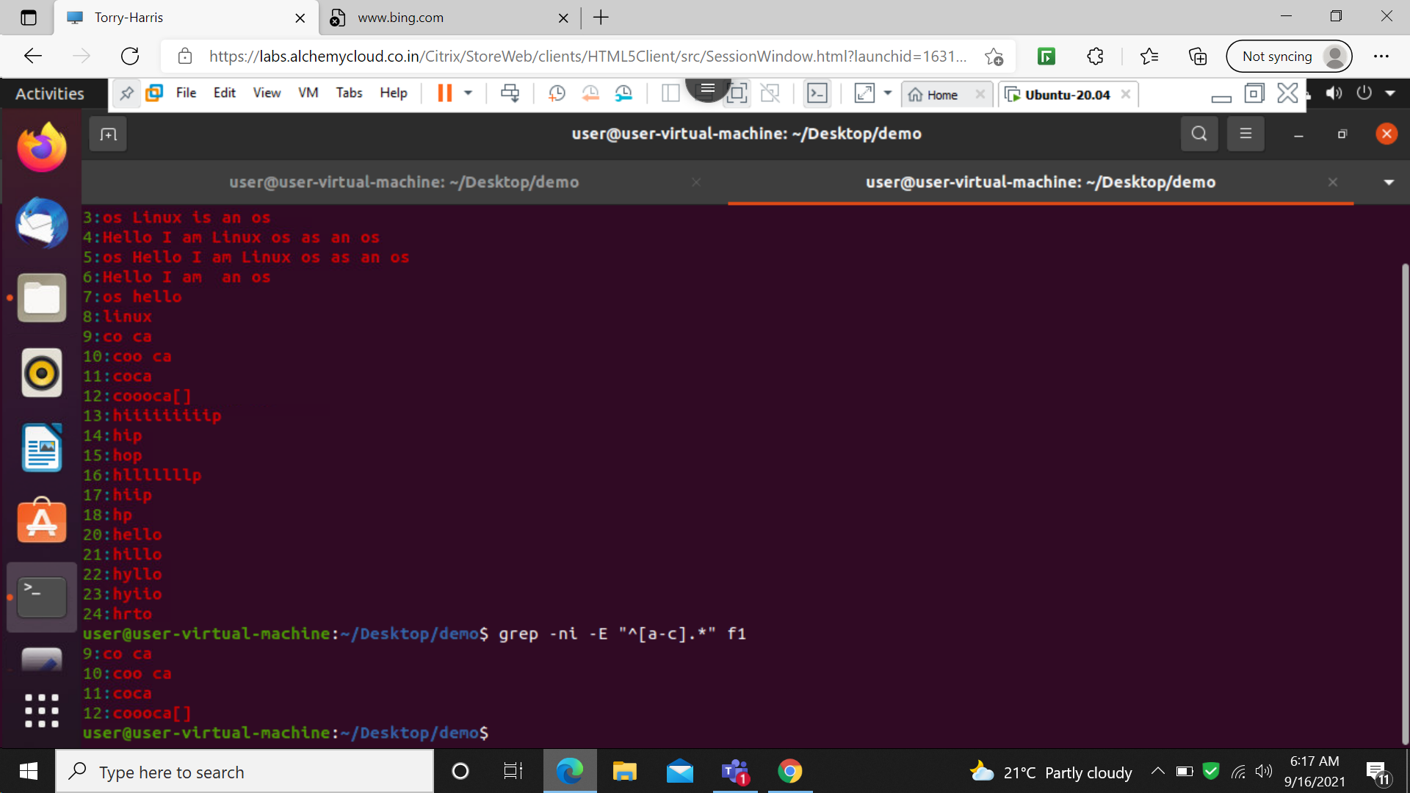

39 : grep –ni –E “[0-9].\*$”

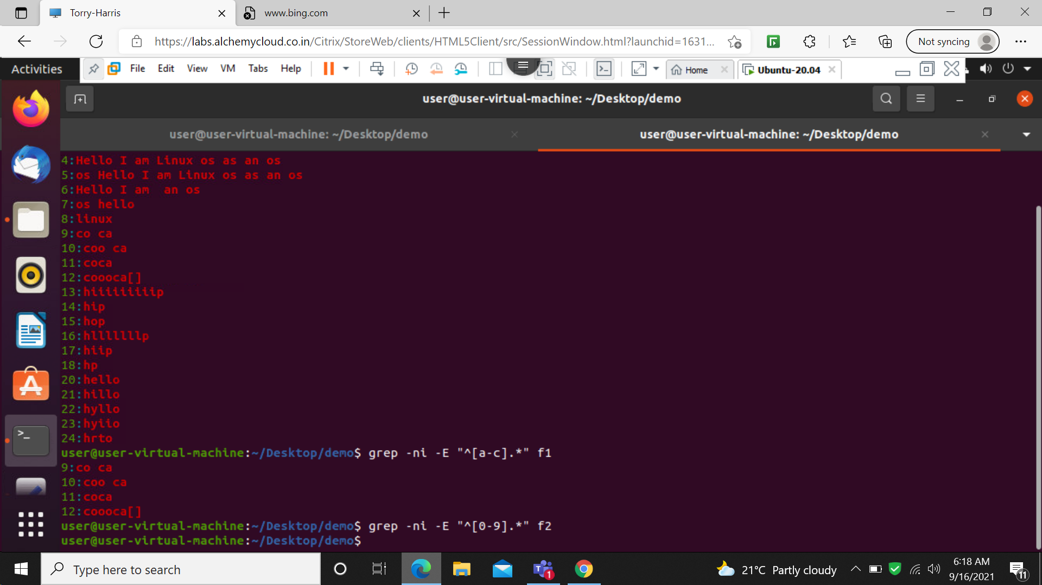

40: grep –n –E “^h[^I] $

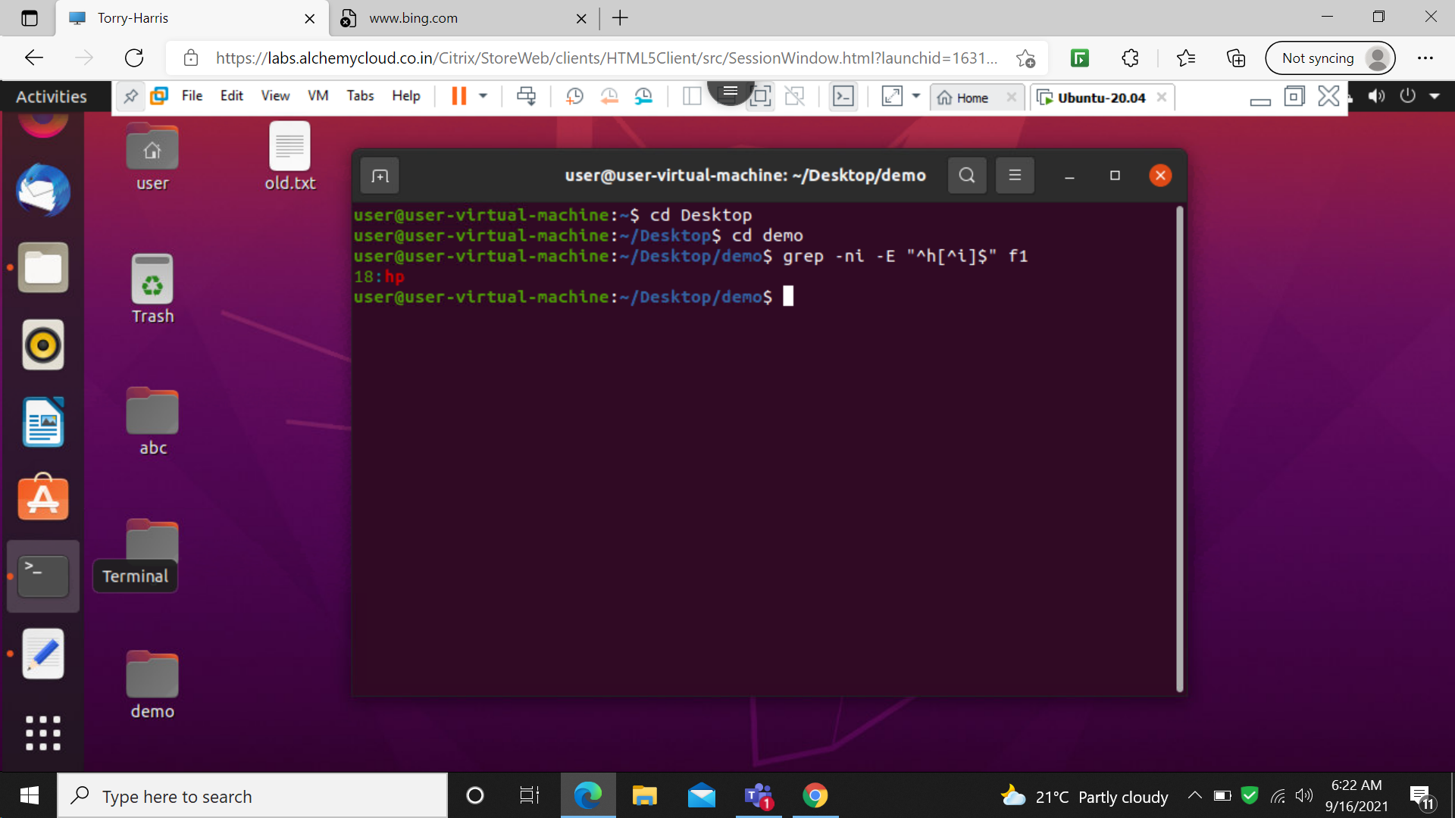

41:grep –ni –E “ ^h.\*o$”

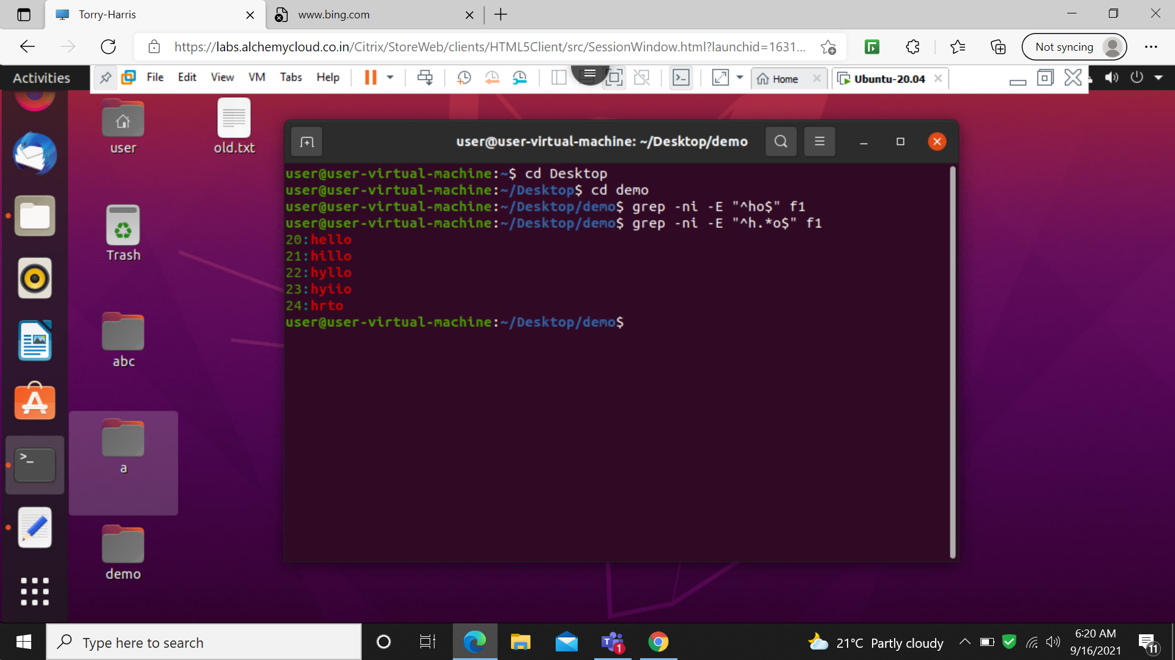

42: grep –ni –E “ ^h[^l]\*o$”

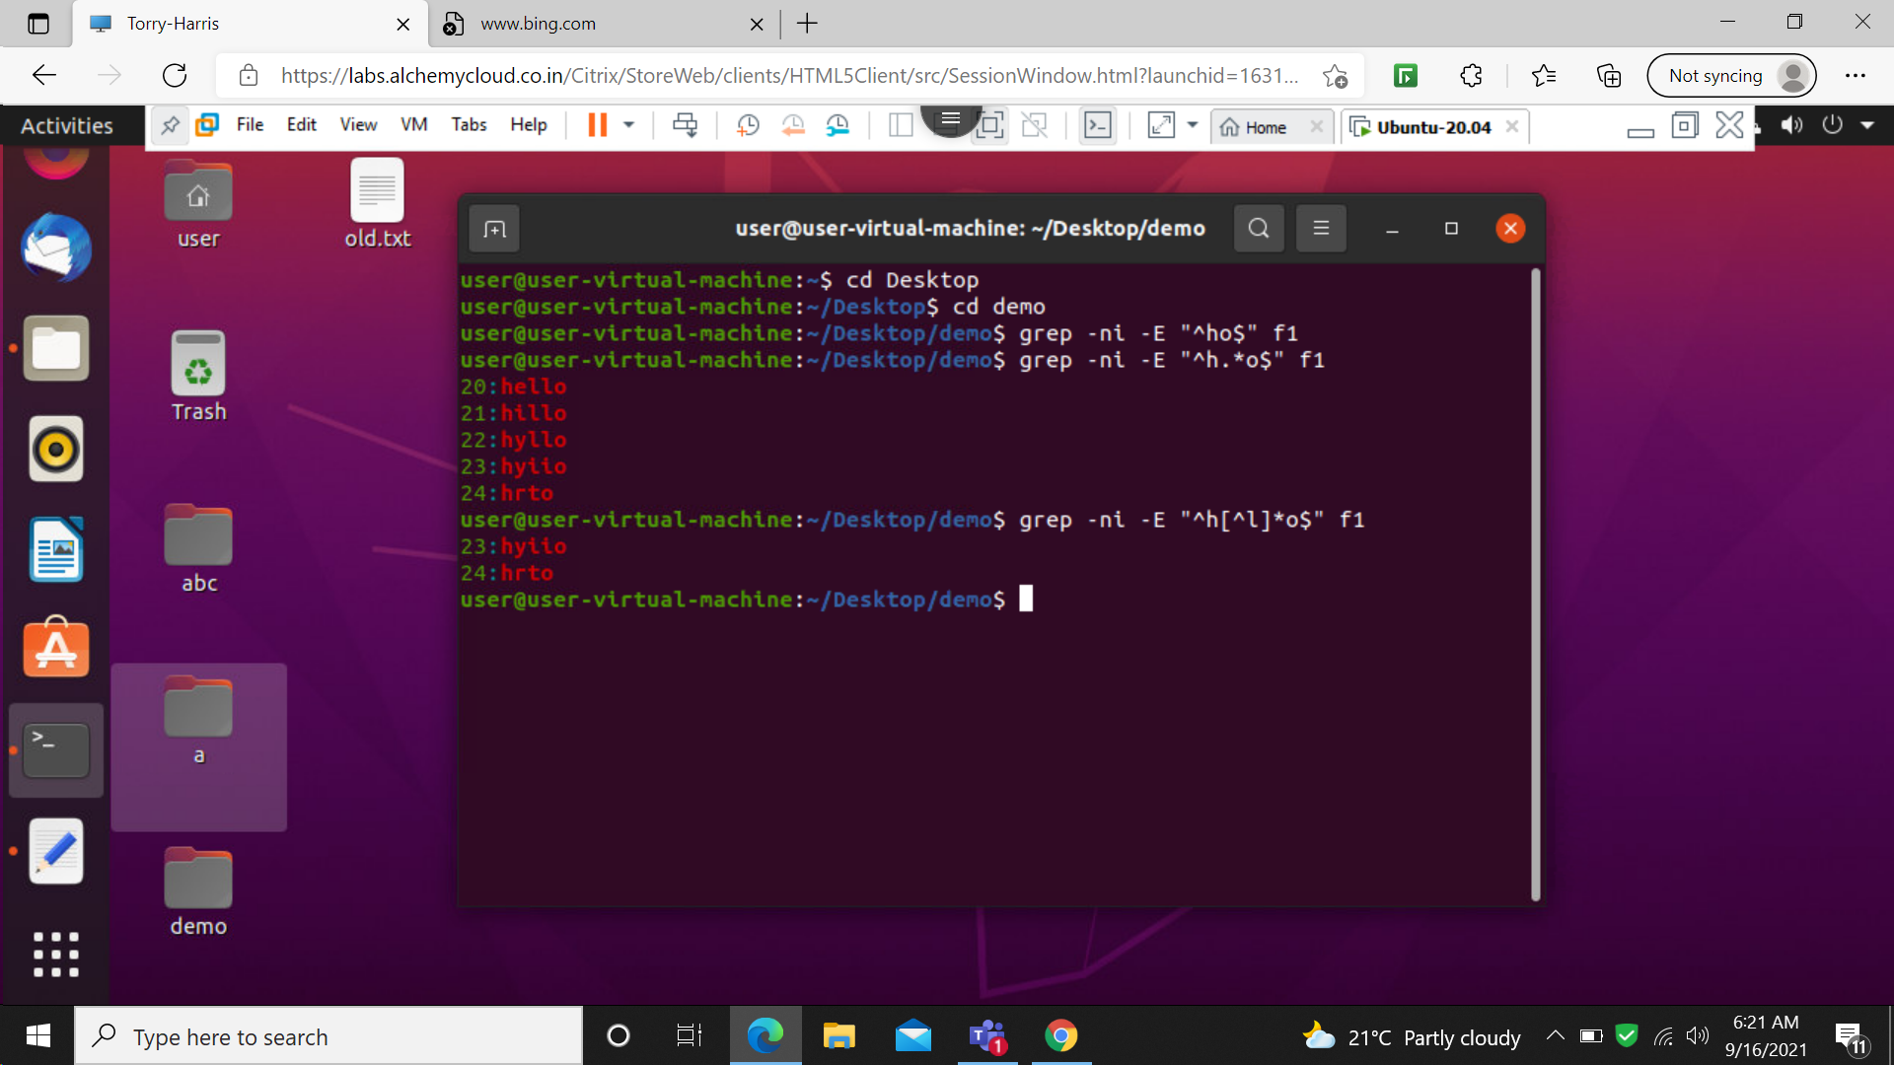

43: cut –c 1

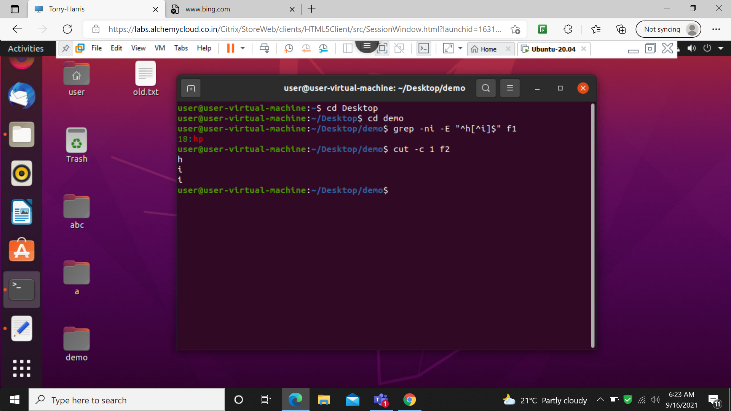

44: cut –c 1-4

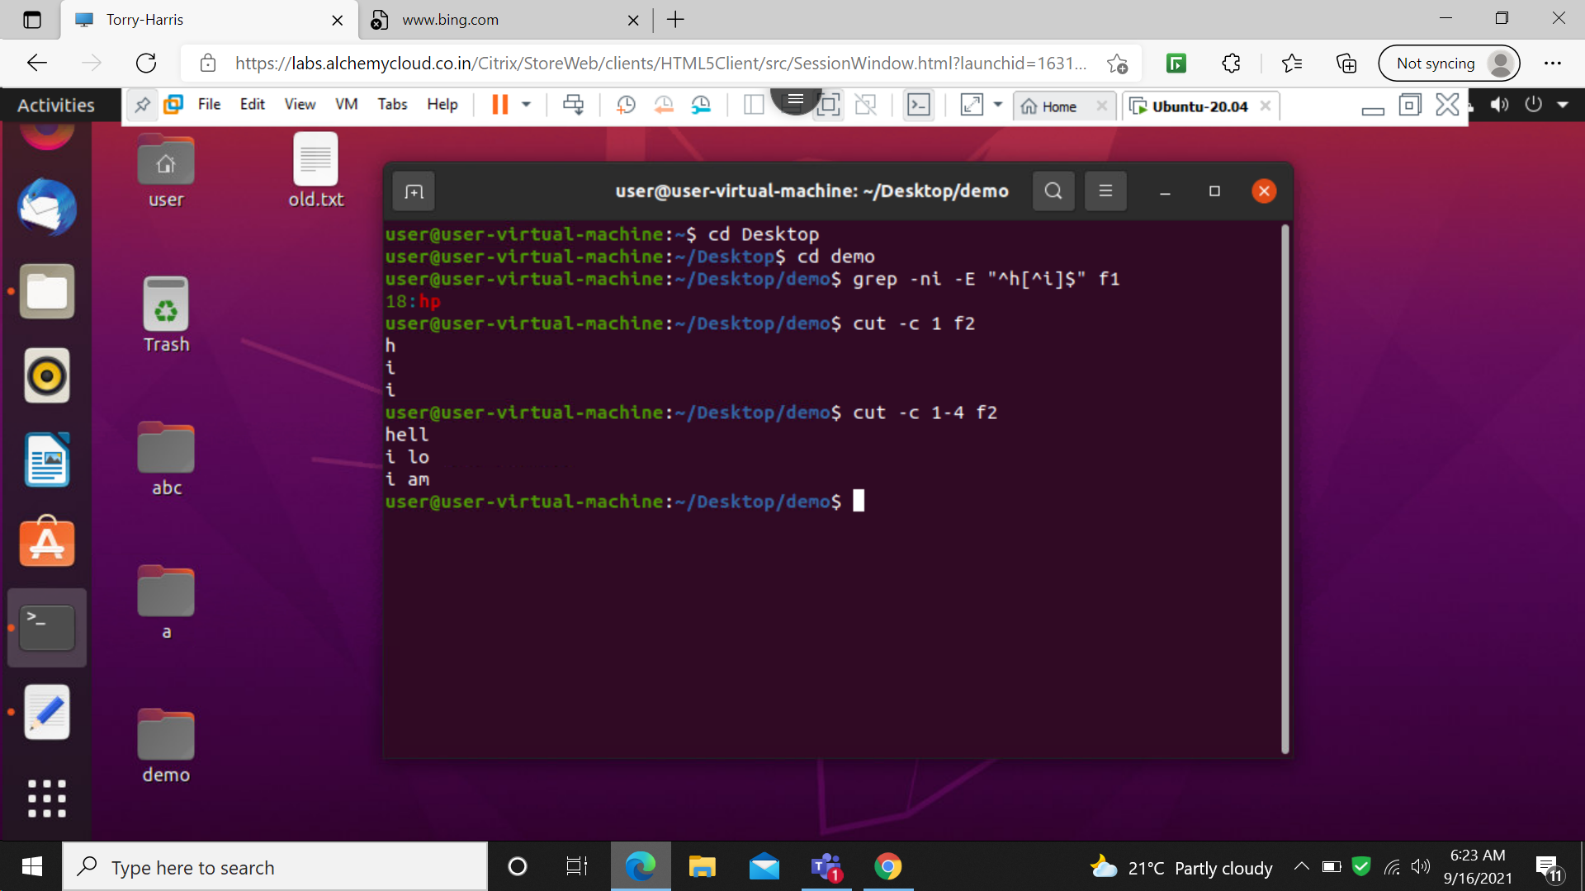

45: cut –c 1,4

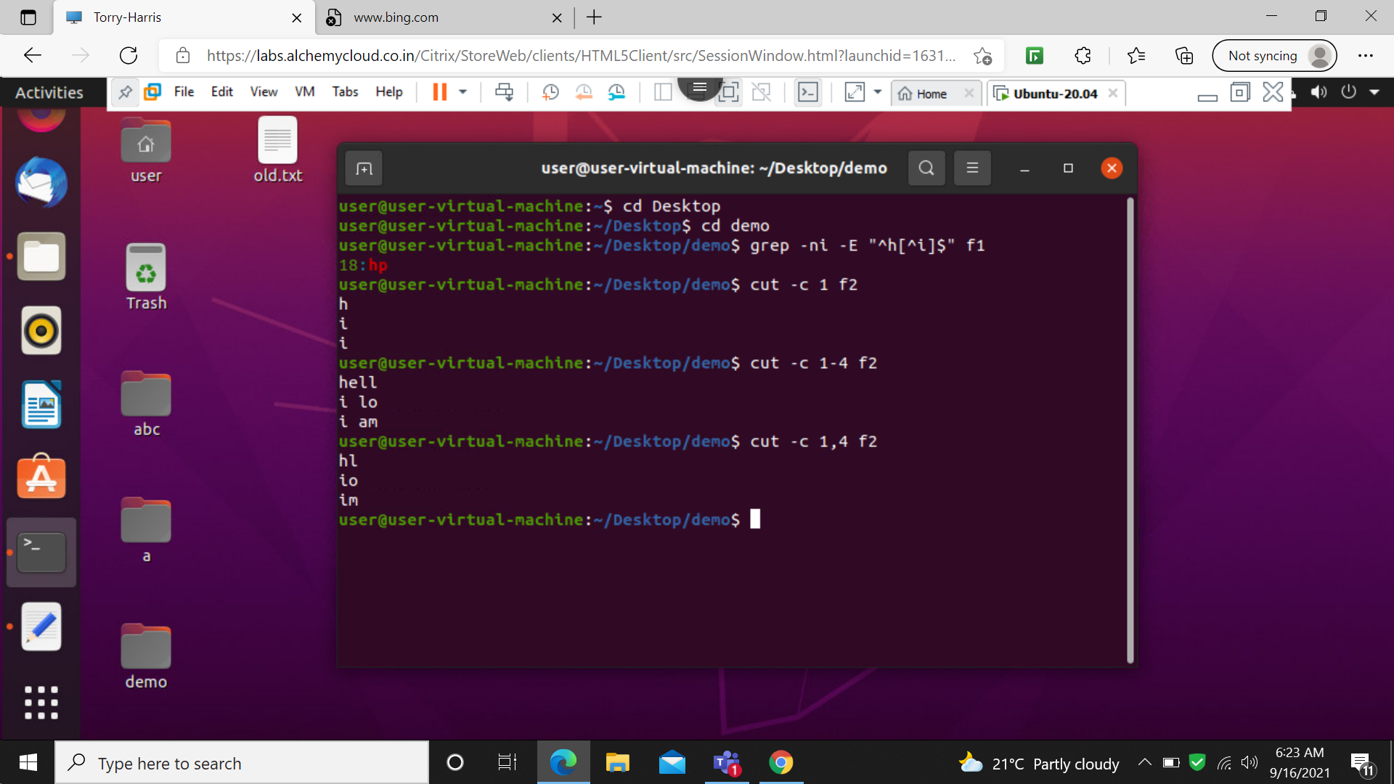

46: cut –c 1-

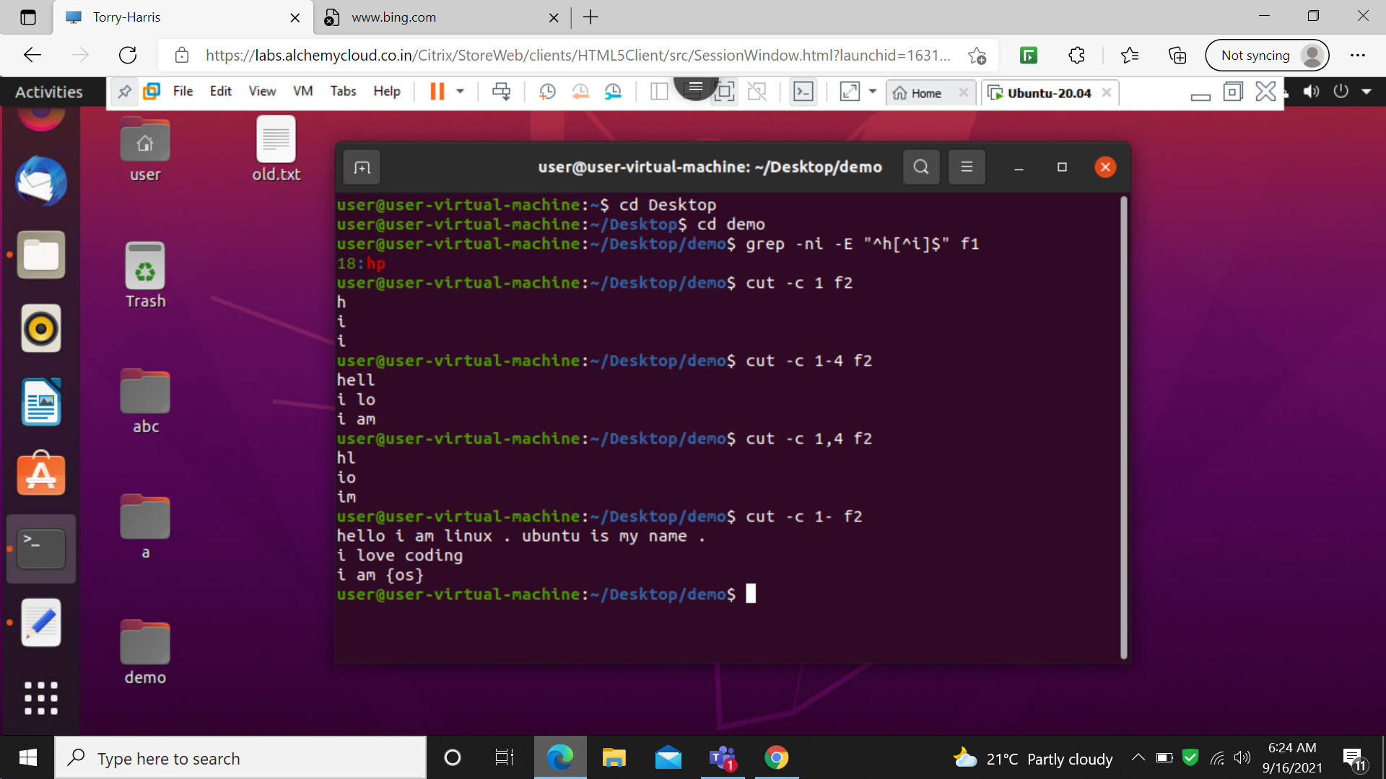

47: cut –c –5

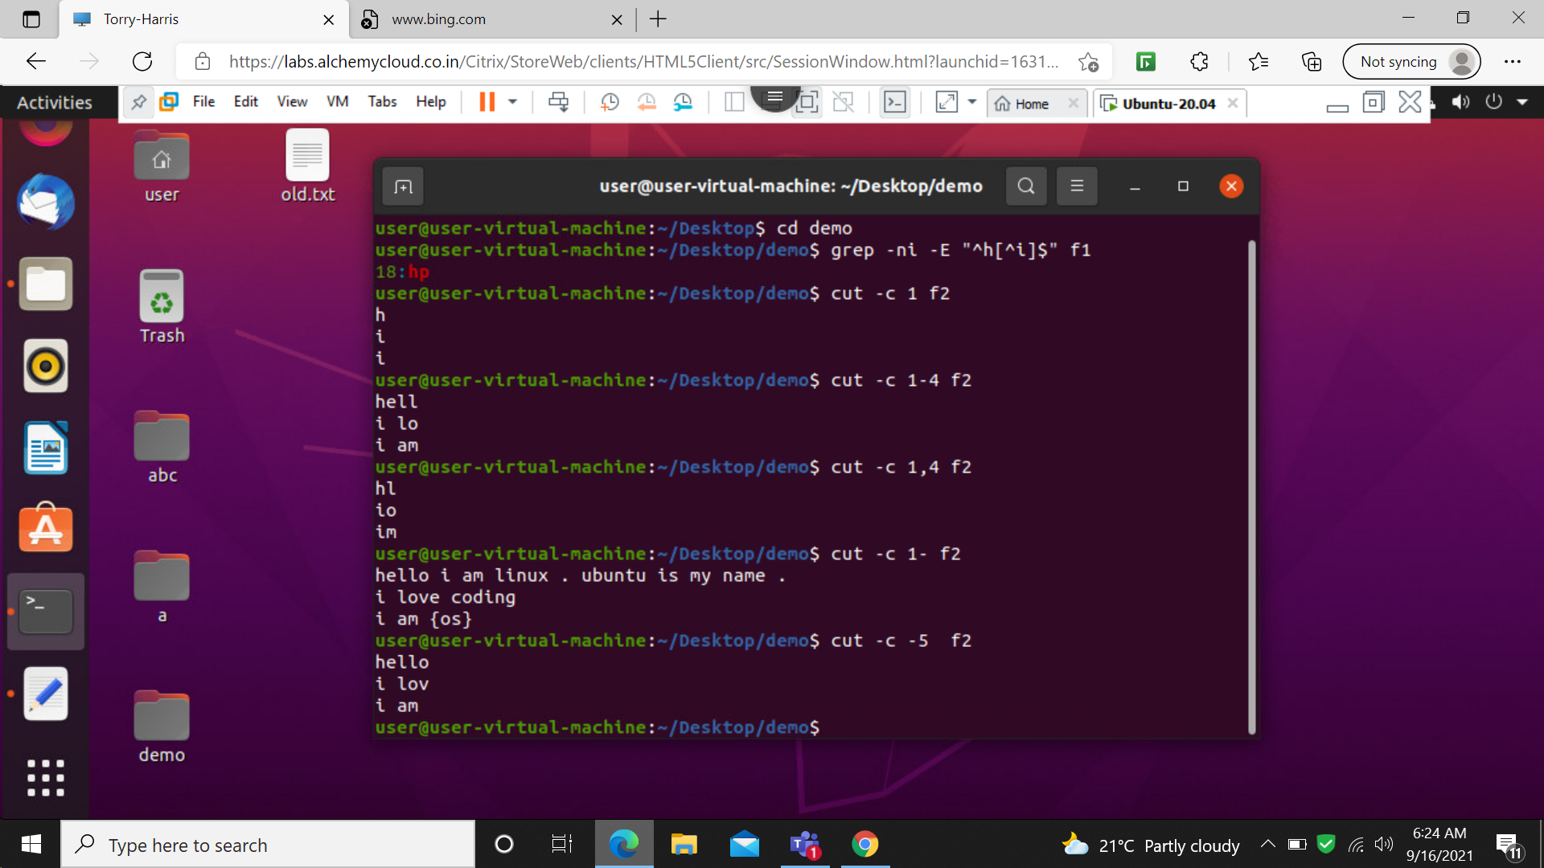

48: cut –b 1

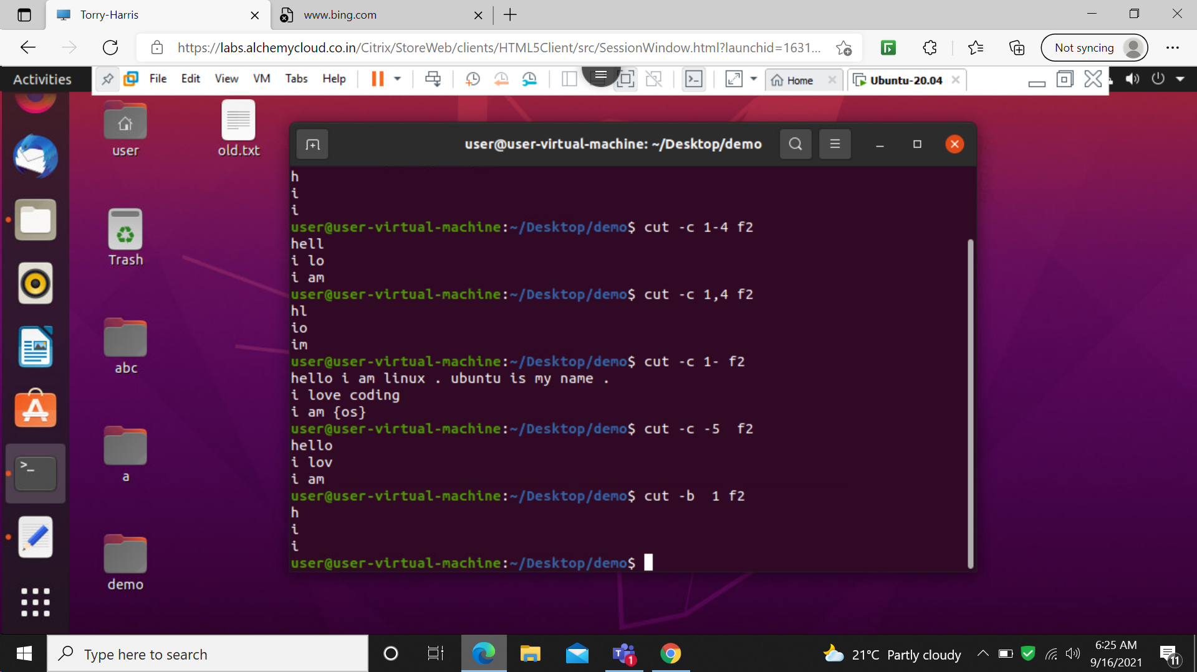

49: cut –f 1

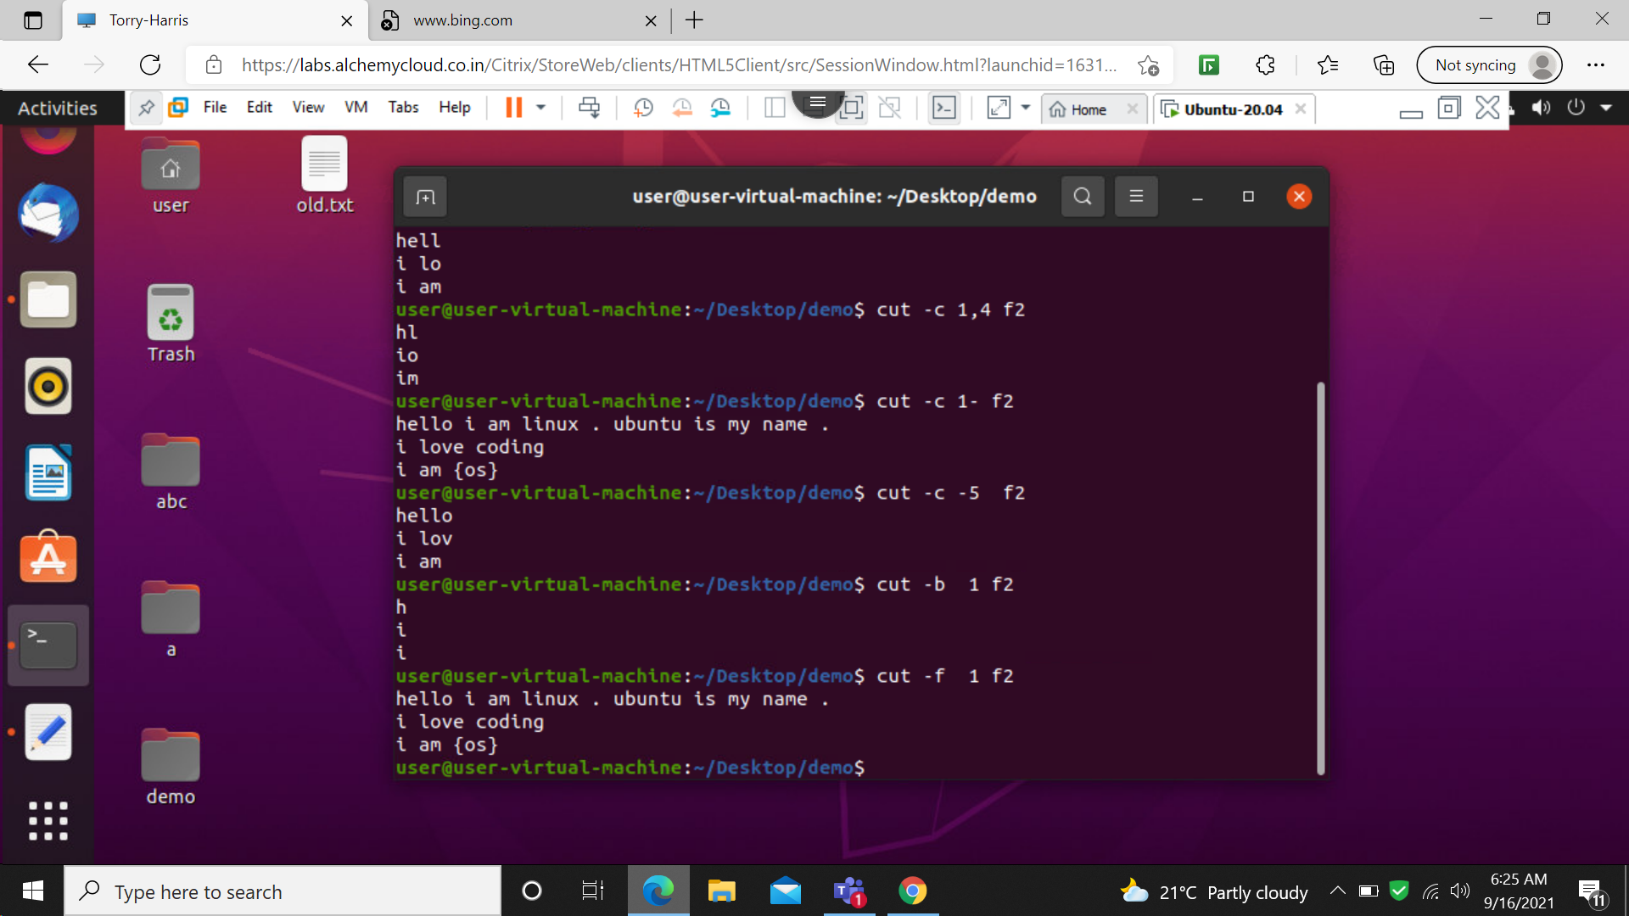

50: cut –d ‘ ‘ -f 1

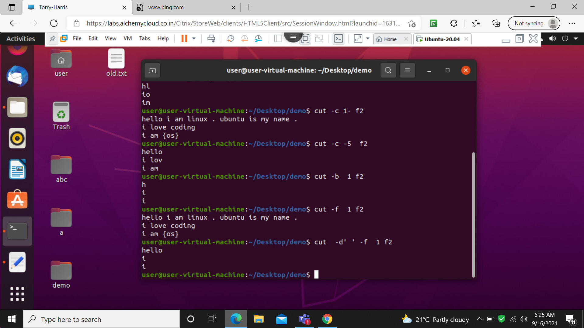

51: cut –d ‘s ‘ -f 1

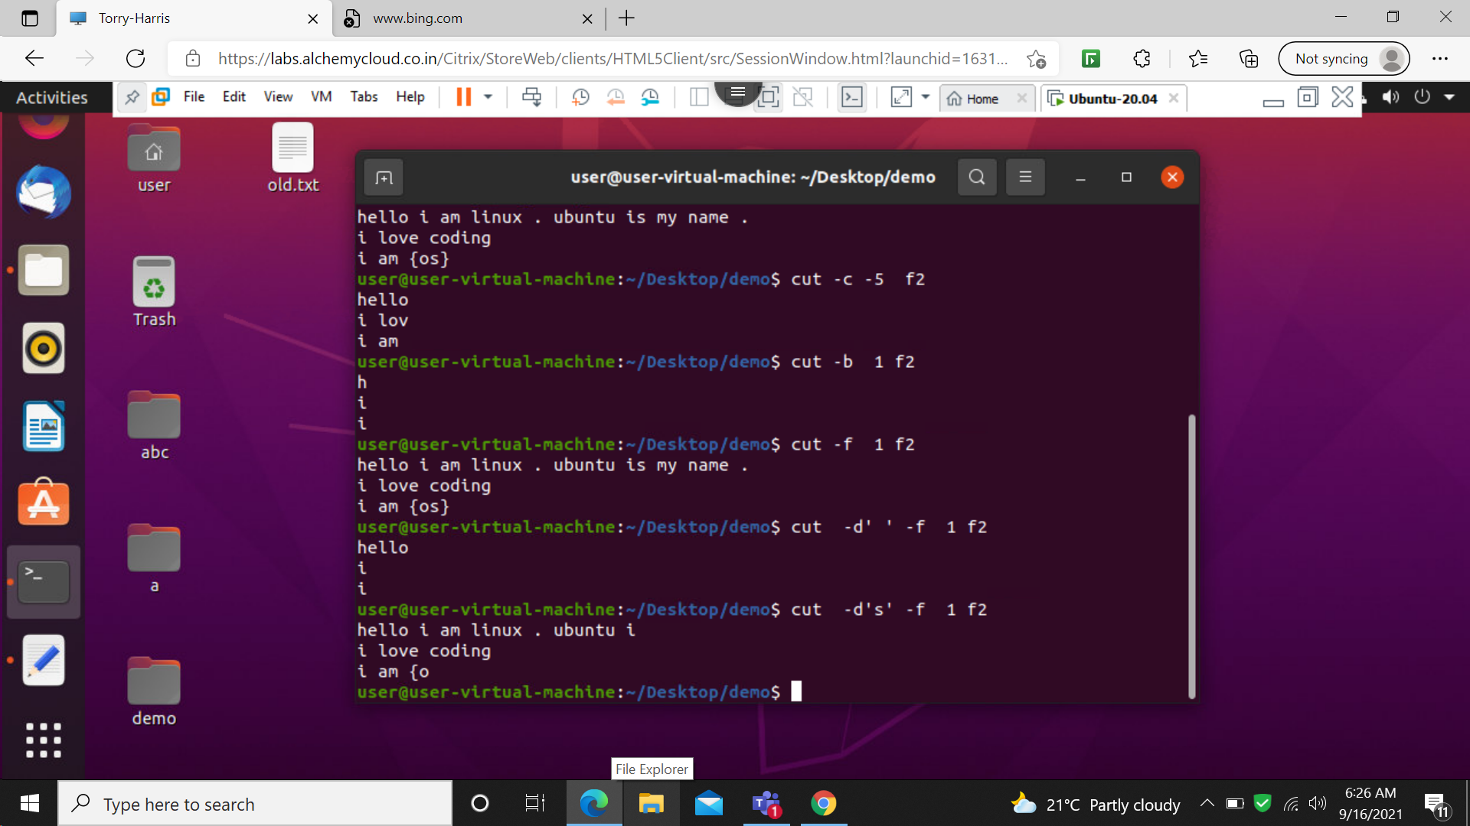

52: cut –c 1,5

